Niven’s news
(September 2023)

Dear friends,

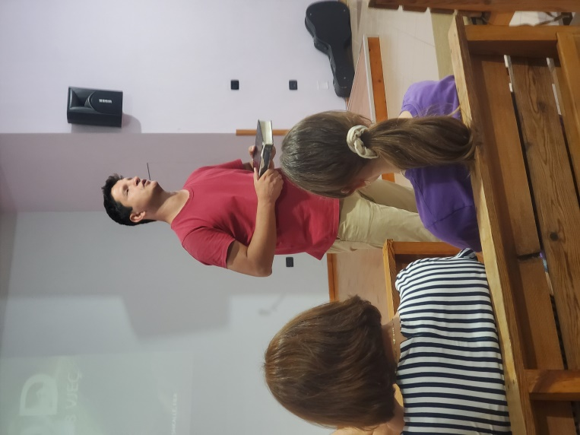
The last week has been hugely encouraging for us as a church in Fier. For the first time we have held a holiday club for the youth in Fier and Patos without the help of a team from the UK. Anything from 12 to 20 young people came each evening last week for a mixture of Bible teaching, games and discussion groups. One of the highlights was to see our girls leading the games so well and helping lead discussion groups. Another was to hear Ori and Bledi proclaim the Word so powerfully to the teens. Our theme for the week was “Exodus” and each day we took a major event from the book of Exodus. After discussion groups one of us gave a short message (James and Will shared the remaining messages). It was so encouraging was to see the attentiveness to the Word and to see the enthusiasm of the young people each day. Please pray for gospel fruit. Pray too for those in Fier who will restart the youth and children’s meetings this month. Pray for Bledi (seen on the right) as he leads these meetings alone in Patos; pray that he would have help and that he would see conversions!

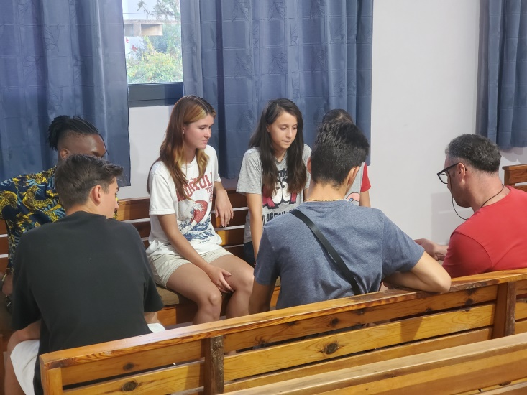
Pray for other meetings that are beginning again after a break over the month of August. Pray for the Bible studies and prayer meetings beginning in Fier and for the blind meeting as well. Pray for Thomas Fleming as he preaches to the blind and also leads a monthly couple’s meeting in Fier and Patos. Pray for the ongoing ministry of the Word in both churches as Will, Bledi and James share responsibility for this. Praise God for good numbers coming to the Patos bible study and for the new understanding that believers are getting from the Word. We are encouraged in conversation with believers to see lights coming on in people’s minds. Pray that the Word would go from minds to hearts to transform lives.

Last month we received a request to begin a Bible study in Levan. We already have teenagers and prisoner’s families coming to the Fier church from this town and have long wanted to see a work begun there. At present there is no evangelical witness and we long to see a church established there. However, we have a distinct lack of workers to sustain such an initiative. Pray that God will supply workers who will be able to spearhead this work.

It was a joy to be able to preach again at the Faith Bible church in Tirana last month. Will preached on spiritual warfare and we had a delightful time of fellowship with the church. Pray for the pastor, Fabi, facing great pain from hernia in the back and for his overall health which has not been good of late.

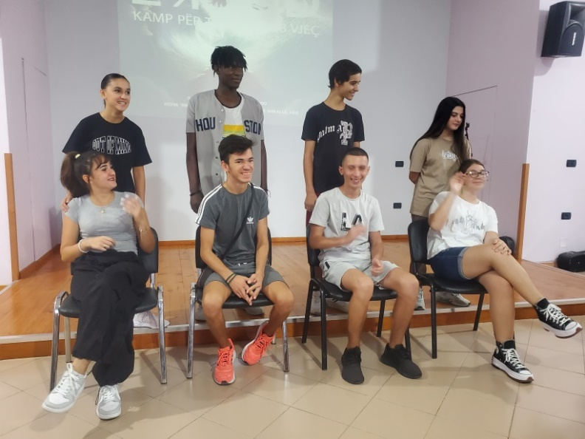
Please pray for Israel our Nigerian brother as he begins the Bible school that our Ester did in Ersekë this month. Israel served at a number of camps during the summer (as did Ester and Lidia) but his injured knee prevents him from playing for a football team. Pray that this will be a time where he deepens his Biblical understanding and pray for him as he serves with the Iron Sharp football ministry in Ersekë; he met a number who are part of the ministry at a football camp and is keen to be more involved.

It has been a blessing to see the men in the Patos church work so hard to renovate the church house. A new roof and a new front porch were put on by workmen but new pavements were laid by the men and they have cleared away all the rubble and refuse. We plan to put in new outside doors and repair the outside rendering this autumn. It has been an even greater blessing to see church members really grasp some central truths of the Word that they had not understood for years. Please pray for the church to grow spiritually and in number. Pray for a retired couple considering baptism and pray an autistic man who has begun to attend our meetings that he might know Christ.

Please pray for us as we travel to the UK for a few weeks. We plan to have a holiday with Will’s Mum and then are going to the 50th anniversary celebration of Grace church, Yate. Will has been asked to preach at this occasion so pray that God would use His Word mightily. Pray that we would have physical, mental and spiritual refreshment during this time.

Pray too as we plan a conference called “Church in hard places” with a number of Albanian pastors from both Albania and Kosova in mid-October. A team from 20 schemes is coming to minister at the conference and we hope that this will be an opportunity for pastors and church planters to learn biblical principles about church planting. Pray for the team coming, for the organizational side of the conference and for Will as he gives the opening address.

Wishing you God’s richest blessing,
Will and Doreta

