Niven’s news
(July 2023)

Dear friends,

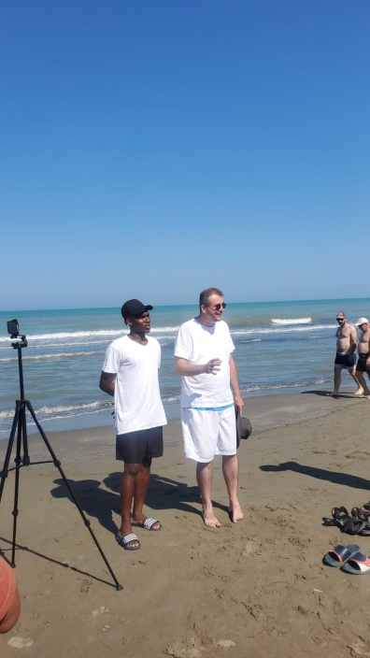
We rejoiced greatly in the baptism of our brother Israel from Nigeria last Sunday. Israel has been playing with the local team in Fier, Apollonia, and has been very much part of the life of our church. It has been a delight over the last few months to alternate with James Goodman in doing Bible studies with him; he is a sponge for Bible teaching and has a humble spirit. So it was our joy to see him baptized and become a member of the Fier church. Please pray for him that he would continue to grow spiritually. Pray too for his future. A knee injury, made far worse by the club giving him pain killers and sending him on the pitch, has put his career on hold. We plan to send him to the Bible school in Ersekë in September so that he can grow in faith, recover physically and get involved in the football ministry there.

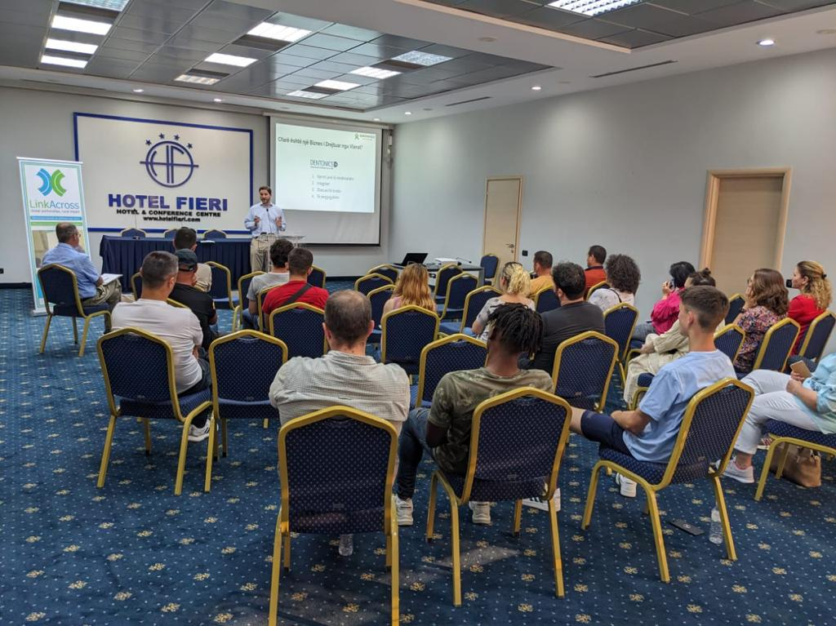
It was a great encouragement to begin our Growbiz business training scheme. Over two nights we were able to hold seminars in Hotel Fieri about “values based business.” The Growbiz team, based in Tirana, were joined by Jonathan Barber from Yate. We were expecting Geoff Todd from Inverness but problems with flights meant that he could only join us via Zoom on the second evening. We also were joined by Festim Hoxhaj, a local pastor who has his own small business, who was very helpful in what he shared from an Albanian perspective. The materials were excellent and well received. It was great to see Ermal, who was part of the Bible study we led in the Fier prison, being part of the seminar. He has started a private courier service in Vlora and is part of the Brethren church there. He is also looking to start a new business. Another encouragement was to see a number of others who have had contacts with churches in Fier and Ballsh come to the seminar. The next phase is to have business coaching; helping people form business and financial plans, to think through marketing and testing the market. Pray that we would have uptake on this and that we can give some micro loans to new businesses.

The family, minus Will, left this morning for camp in Ersekë for a youth camp. Ester and Lidia will be leaders and Samuel a camper. Bledi has a group from Patos there and this year he is the speaker at the camp; please pray for God’s blessing on His Word and pray that souls would be saved. Pray too for Will as he prepares for the blind camp beginning on July 25th. He is speaking four times on the theme of “Christ is King” and will be joined by Arjan Kacimbro, one of our blind brothers from Korçë, who will preach one night. Pray for our preparation. Pray for God’s Word to be blessed by the Spirit to bring salvation. Pray for our discussion groups and for all the conversations that we will have during the week about the faith. Pray particularly for Niko Hamzallaraj who is organizing the camp that he would have stamina and wisdom as he deals with campers with different needs and requests. Pray too for us as a board, of the Light to the Blind foundation, as we meet together to talk about future plans. We are thrilled that a new group has begun in Billsht with the help of Arjan.

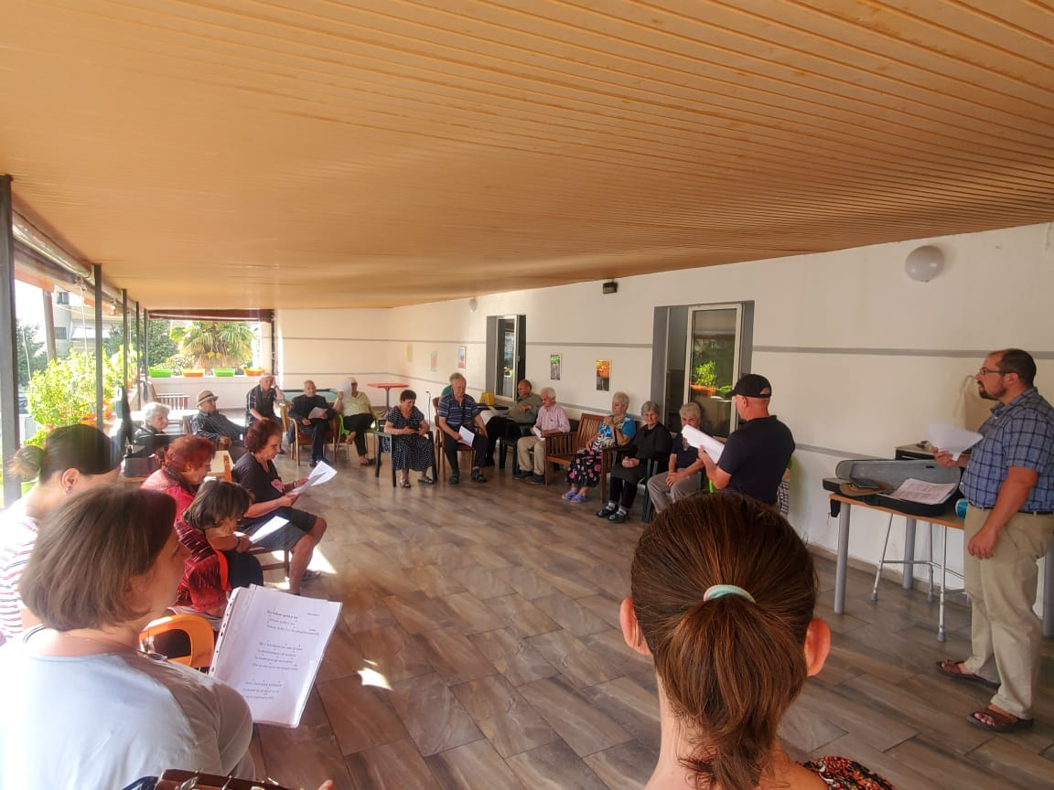
We praise God for the way that He has helped our girls through their exams. Lidia has finished her end of year exams but Ester has one more. One of her exams was particularly traumatic. At the start a number of students just handed in a blank sheet of paper and left; their grades were already decided! Then at the end the professor graded everyone, together with the professor who had led the practical part of the course, right in front of the class! She wanted to fail Ester but the other teacher insisted that she deserved a pass for her practical work. Around three people passed in the end, including Ester, and the rest failed. Ester felt that she deserved far more but was just relieved to pass; some spend years trying to pass this professor’s courses! The favouritism and corruption in further education here is a major issue. Pray that the girls will continue to stand for Christ and be women of integrity. Pray too for Ester’s health; she has been having stomach problems of late.

Pray for pastoral situations in the Fier church. We may lose a couple because of a sin issue that we cannot as a church sweep under the carpet. Pray that the wife, who is in sin, would repent and that they would be restored. Pray for those struggling with particular sins and temptations at the moment. Pray too for our series in midweek meetings on our distinctives as a church. I believe that this series has been very helpful so far but do pray that the church would mature and deepen in its understanding of the Word. Pray too for our outreach to the old people’s home in Fier (see photo on right). James Goodman preached very helpfully there last month and we are having some profitable conversations with some who want to know more about what we believe.

During the summer the children’s and youth meetings are taking a break. Pray that the workers will be refreshed spiritually during this time and pray that the children and young people will not forget the Lord! Pray for our planning in Fier as we seek to organize a holiday club for the youth during the first week of September. We hope to have youth from both Fier and Patos. We also hope to have some social time with the young people through the summer to keep up contacts.

Wishing you God’s richest blessing,
Will and Doreta

