Praying Through This Week 5th September 2022 – Prayer

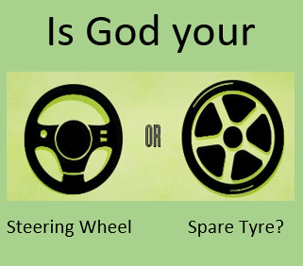

PRAYER – some thoughts...
“Prayer is simply a two-way conversation between you and God”
(Billy Graham)
We love to have conversations with our friends, with our loved
ones, and often seek out any opportunity to do so - And we listen,
eager to hear all that our loved ones want to say to us.
Let us pray for grace and love to seek out any opportunity to talk
with God, with Jesus, perhaps at regular times, perhaps
spontaneously, perhaps in the deep, silent companionship of
shared love and listening.
Corrie Ten Boom asked – “Is God your steering Wheel or your
spare tyre?”
Would it be good also to ask ourselves – “Is prayer my steering
wheel or my spare tyre?” Does prayer “steer” my life or do I use it
only when all else fails?
Pat.

Praying Through This Week 5th September 2022 – Prayer

PRAYER – some thoughts...
“Prayer is simply a two-way conversation between you and God” (Billy Graham)
We love to have conversations with our friends, with our loved ones, and often seek out any opportunity to do so - And we listen, eager to hear all that our loved ones want to say to us.
Let us pray for grace and love to seek out any opportunity to talk with God, with Jesus, perhaps at regular times, perhaps spontaneously, perhaps in the deep, silent companionship of shared love and listening.
Corrie Ten Boom asked – “Is God your steering Wheel or your
spare tyre?”
Would it be good also to ask ourselves – “Is prayer my steering wheel or my spare tyre?” Does prayer “steer” my life or do I use it only when all else fails?
Pat.

