Praying Through This Week 8th August 2022

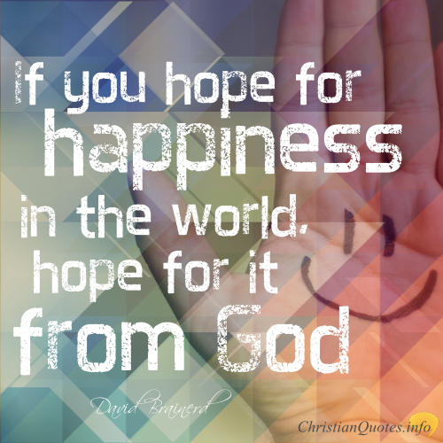

"Happy are the people whose God is the Lord" Psalm 144:15.

We all want to be happy, but sometimes trying to find happiness can be a struggle. Often we search for it in all the wrong places or ways; when the answer is much simpler - God. Scripture guides us to true happiness through knowing the promises in God's Word!

Let us focus this week on our happiness, and ensuring it comes from the right place!

Lord, I long to know and experience happiness in my life.
I’m not talking about joy from earthly things.
Those come and go, and the wrong kind leave us empty and unfulfilled. The happiness I hope for is so much more than skin deep.
I want the kind of happiness that trusts you, obeys you,
and follows you regardless of where that path leads.
Amen
Vicky

Praying Through This Week 8th August 2022

"Happy are the people whose God is the Lord" Psalm 144:15.

We all want to be happy, but sometimes trying to find happiness can be a struggle. Often we search for it in all the wrong places or ways; when the answer is much simpler - God. Scripture guides us to true happiness through knowing the promises in God's Word!

Let us focus this week on our happiness, and ensuring it comes from the right place!

Lord, I long to know and experience happiness in my life.
I’m not talking about joy from earthly things.
Those come and go, and the wrong kind leave us empty and unfulfilled. The happiness I hope for is so much more than skin deep.
I want the kind of happiness that trusts you, obeys you,
and follows you regardless of where that path leads.
Amen. Vicky

