Faculty application for Removal of Pulpit, Reorganisation of welcome area and Temporary Reordering Licence for Altar Frontal

St Pauls, an unlisted church in the Letchworth Conservation Area, is essentially a Decorated gothic building, built in the early 20th Century. The church sits on a triangular site, with a modern Church Hall and Rectory (both to the west). The prominent site is located on the eastern side of Letchworth, at the junction of the A505 and Letchworth Gate. In plan, the Church consists of a mostly clerestoried Nave, North Aisle, short South Aisle, and East Porch. The church has been re-ordered, with the Altar at the west end, and the main entrance from the east. Walls are knapped flint facings on a brick core (all bedded in a lime mortar), with limestone dressings. Walls are painted plaster internally (though some walls, intended as temporary walls ahead of future expansion of the church, are painted brickwork). The building was planned in 1919 as the ‘Victory Church’. The original design was prepared by architect Arthur Heron Ryan-Tenison (1861-1930), and was to consist of “a choir with ambulatory transepts, a nave of six bay, recessed at the west end as a baptistery, north and south aisle, and a massive tower, centrally placed at the crossing, a lady chapel, sacristy and priests’ vestry, organ chamber, and other features”. The building work proceeded in three phases from 1923 to 1939; the church remains unfinished according to the original design. The Church Hall was erected in the late 1950s to a design by Hugh Bidwell (who was also responsible for the later extensions). In 1990, the main worship space was re-ordered (with the altar moving to the west end), and a new East Porch constructed as the main entrance to the building.

Removal of the pulpit
The pulpit is no longer used for preaching which now takes place centrally using a simple portable lectern. The removal will allow more space for the Worship Team pre-service meeting in the Sanctuary especially now with social distancing under Covid19 restrictions. It will also allow freer movement for congregation members receiving the Sacrament. In May 2019 removal of the pulpit to create more space featured strongly in the results of the consultation undertaken with members of the congregation on how to improve the working of the church.
Faculty Approval is sought for the careful dismantling and removal of the pulpit and the making good of the flooring where necessary. It is hoped that the panels will be reused in the welcome desk below if practical and economic. Otherwise it will be stored until it can be reused elsewhere or if not its appropriate disposal.
The Welcome Area
The eastern end main entry point for the church is where the Welcome Team first meet the attendees at a service and where interaction often occurs after the service. It is restricted in width and the northern side has a mixture of tables, access steps to the raised audio visual desk and separate cupboards for service sheets and other items. With the improvement of modern technology the raised audio visual desk is twice as long as is now needed.
The welcome is the first part of a service where we are able to make people feel part of the community of St Pauls. Also as an architect I know the entry point to a building is important and sets the scene for the rest of the worshipping experience. The area to the north of the doors is cluttered and has been added to over the years. Now is the time to ‘de-clutter’ and provide a simple solution to the area.

Faculty Approval is sought to half the size of the modern audio visual desk and move it a short distance with the steps up against the adjacent pillar; also remove the two existing tables and cupboards housing service sheets and other items. This will provide space for a commissioned table / cupboard on casters positioned between the font and east wall which will be set back a little giving more space around the entry doors for the welcome team. Consideration will be given to reusing the panels from the pulpit if practical and economic. Access to the audio visual desk and the cupboards under the table will be via the north side of the font. Without the conflicting access to the existing audio desk, this solution will provide a simple and welcoming entry point to the church.
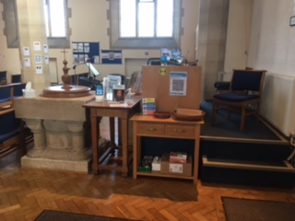
Welcome area as existing above Proposal for welcome area below
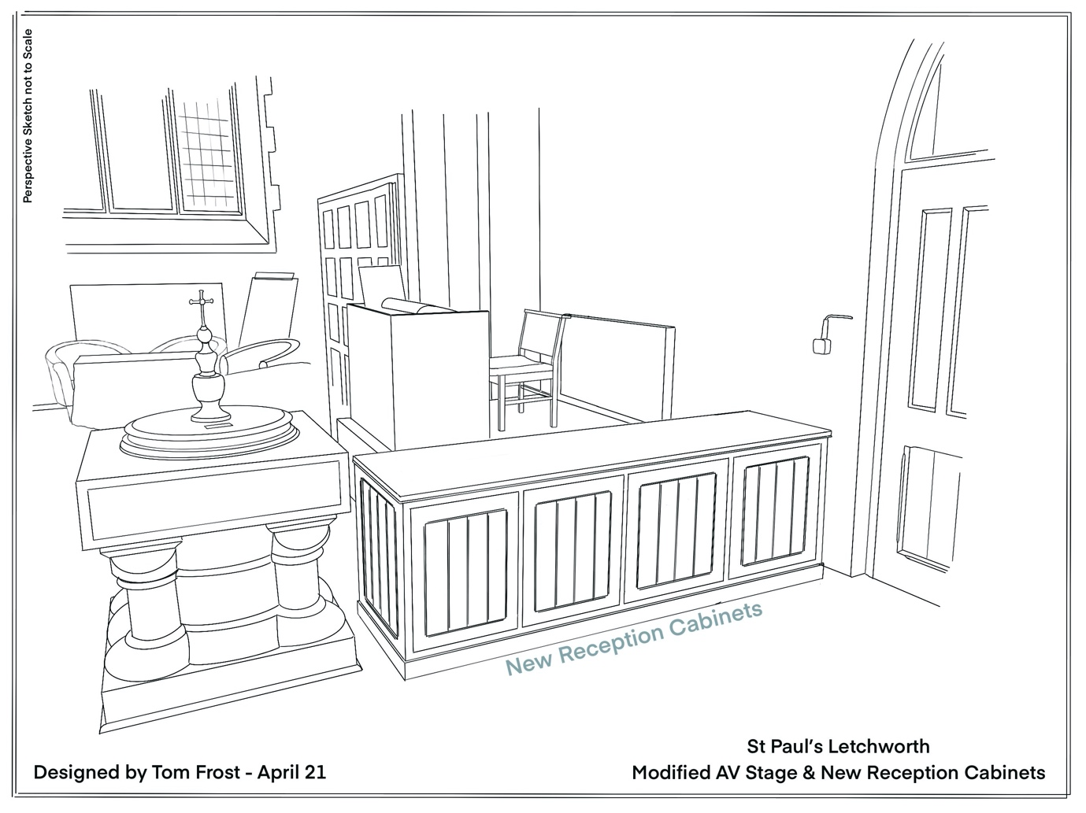

Temporary Reordering Licence for the Altar Frontal
The PCC have agreed that the Altar Frontal cloth would benefit from updating as it conflicts with the more recent adjacent hanging. Jill Thompson Snr who gifted the current frontal is in total agreement with this as in her words all things have their time.
A Temporary Reordering Licence is sought to remove the current altar frontal to be replaced by a simple white cloth for a period whilst alternatives are sought and agreed. This will make the altar stand out against the larger Holy Table behind and allow time to discuss and agree a long term solution.

