Niven’s News
(June 2021)

Dear friends,

Last Sunday the Fier and Patos churches met together to witness the baptisms of 7 people. It was an immense joy to hear the testimonies about how God has worked in each one and to be able to welcome them into the church. We were especially encouraged by the number of non- Christians who were present. One of those baptized, Besnik, comes from a family that is radically opposed to the gospel. Yet his brother and family came and listened attentively to the Word. It was a wonderful opportunity for Will to preach the gospel. It was also encouraging that the men from Fier and Patos led every other part of the service. Praise God for the commitment made by these 7 and pray that they would grow in Christ. Pray for gospel fruit and for those who are sitting on the fence to commit themselves to Christ fully to following Jesus.

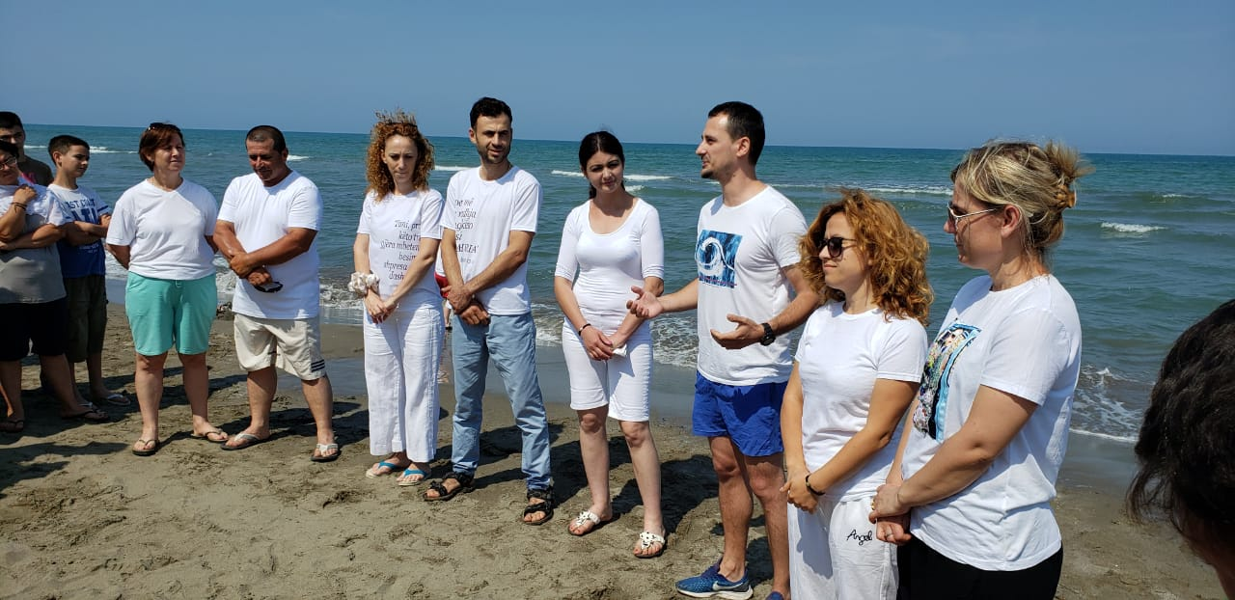
Baptismal candidates giving their testimony

Before the baptismal service we had another training session with brothers from Grace Church, Yate. This was focused on who deacons are, what they do and how we should choose them. The material was very helpful indeed leaving the men with much to think about. What really blessed us was the fact that the men accepted nothing blindly and had quite robust discussions about whether the teaching was Biblical or not! We are so thankful that the men are growing in discernment and thirsty for teaching. Pray though that they might put into practice what they have been taught and pray that we might see deacons and elders rise up from among the churches in Fier and Patos. Pray for the new trustees (James and Sandri) who are going to be serving the church in Fier in a practical way. Pray for us as we navigate big changes in the tax system and how we operate as registered charities here.

Please pray for our involvement in camps during this summer. Will received an emergency call from Ersekë last week as the speaker for their football camp is unable to come. Pray for Will as he prepares 5 talks in 2 weeks in the midst of other commitments. Pray for Samuel and 4 other lads from Fier who will be campers that God would work through His Word powerfully in their lives and in the rest of the campers. Pray for the “Light of life” camp for the blind and partially sighted (25th to the 30th of July). Again, Will is speaker at this camp. Pray that some from Fier and Patos whom we have helped through the pandemic might come and that we might see God working in this community. Pray for Niko Hamzallaraj as he leads the camp and for the Light for the blind board as we have a board meeting during camp. Pray too for the young people going to camps from Fier and Patos for the first two weeks of August. Pray for Ester and Lidia as they serve as volunteers at camps this summer that they might grow in faith and be used of God.

Please pray also for other outside commitments this summer. Pray for Will as he preaches for the “Light of the world” Baptist church in Tirana for their 20th anniversary this coming Sunday. Pray that this will be a great encouragement to the church. Pray too as he continues his series of monthly sermons on the doctrine of salvation for the Disciple’s church in Tirana that God would use His Word greatly in people’s lives. Pray for Will and James finishing their series, “Salvation belongs to the Lord” in July. Pray that people’s understanding of God’s work would increase and that the Fier church would be moved to wonder, love and service to God!
Pray that God might stamp out corruption in Albania!
This week the World Bank issued statistics that show that Albania is the second most corrupt country in the world. According to them only Zambia is more corrupt!

Pray too for wisdom as a church now that the restrictions due to the pandemic are being lifted. During this time have not been out to the villages or done children’s or youth work in person. We have not been allowed into the Old People’s home in Fier either. In the autumn we must decide which ministries to begin again and we have great need for workers. Pray that church members will really respond to the needs but also that we might have a couple to work particularly with children and youth.

We are so thankful to God for helping Lidia through her final exams of high school despite the disruption caused by Covid and some challenging conditions. In one exam people just stood up and asked for answers from others. Teachers encouraged hard working students to help lazy ones with the answers and copying was rife. You can imagine how demoralizing and depressing this is for young people who do study well. Pray that Lidia will be guided to the right university course and that she will continue following Christ. Pray for Ester doing university exams for the next month. Pray for our health and strength in the heat of the summer; temperatures have already risen to 40 degrees!

Wishing you God’s richest blessing,
Will and Doreta

