LEGO LENT (3 week) CHALLENGE
by Naomi Elliott

In 2020, I created a daily Lego Lent challenge on Facebook - each day of Lent (except Sundays) I presented a new build challenge and anyone who wanted to could build something in response. If they wanted to they could read through the short blurb attached to the image which tied the challenge into the story of Holy Week but there was no pressure to do so. If they wanted to they could share a picture of their build in the comments below the challenge post but again there was no pressure to do so.

I presented each challenge with a Lego number showing the day of Lent we were on and wrote the challenge as a caption for that picture. The creations people shared were wonderfully varied, included cars and a hot air balloon by one keen dad for the first challenge.

For 2021:-
START Monday 15th March.
This is a 3 week interactive challenge (keeping Sundays a rest day) engaging with the events of Holy Week. Each day simply post the image with the caption in the right order, and invite people to share pictures of their creations under each challenge! You should reach Day 18 on April 3rd, the Saturday before Easter Sunday.

- The king needs to get to the capital city. DESIGN A VEHICLE FIT FOR A KING!
Two thousand years ago there were no cars or planes, limousines or spaceships. 2000 years ago in Israel (the country Jesus came from) the fastest way to travel was probably horse and chariot and sailing ships. Horses were used by soldiers and army generals and people used donkeys and camels to carry them as well as to carry their things for them. Most people walked everywhere. But what about a king?
Jesus travelled to the capital city on… a donkey! Actually, a donkey’s colt – a young donkey that had not even been ridden before. This was the way the ancient kings of Israel had entered the city. Israel hadn’t had a proper king for ages and another country – the Romans – had taken over their country. Jesus wanted people to know that he was the king they had been waiting for.
Imagine if Jesus came to visit you today: how do you think he would travel to get to you?"

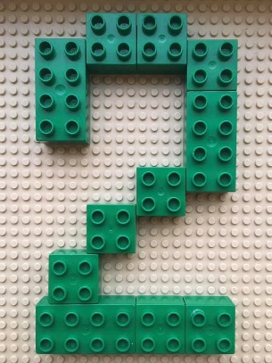
- The walled city needs a new gateway. Can you build a grand new entrance?
Jerusalem was an old and important city. It had a big wall to protect the people inside. It also had lots of gateways to let people in and out. These entrances had interesting names: Golden Gate, Jaffa Gate, Dung Gate! Does your gateway have a name?
People were proud of their city and put a lot of hope in it. Jesus had reminded people that God is really the only thing that won't let us down. Jesus warned people not to put their trust in things by making those things too important. Some people might have lots of money… but it might get stolen. Some people might wear nice clothes… but these will become old and get holes. Jesus even warned that the important city of Jerusalem that the people liked so much would in the future get broken down and destroyed.
I wonder what things are most important to you?

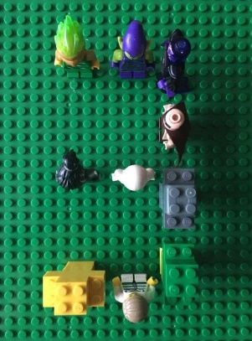
- It’s nearly party time! How many Lego people can you gather or build to fit in one place?
Lots of people were traveling to the city of Jerusalem for a festival. The Passover festival remembers a time long ago when God used a man called Moses to rescue his people. So the city was filling up with visitors and also with Roman soldiers who wanted to keep things safe. There was excitement in the air.
As the crowds noticed Jesus riding the colt into Jerusalem, they started to spread their coats on the floor to make a road for him to ride on. They also cut down some branches to add to their road. This was their way of rolling out the red carpet – treating Jesus as someone famous or treating Jesus like a king. The crowd had been singing their festival songs and were now shouting out these songs even louder, cheering Jesus on. “Hosanna!”, they shouted. “Hosanna! Save us!”
Do you have a favourite song? How does your song make you feel?

- You’ve entered a tower building competition. Will you win?
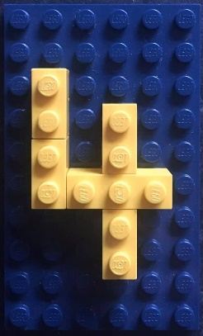
The day after Jesus arrived in Jerusalem, he went to the Temple. The Temple was a bit like a church, although it was a lot bigger than most churches we might know and there was only one Temple in the whole country!
Many old church buildings have towers. Towers are easy to spot, making the church easy to find. Some church towers also have bells inside which when rung used to call people to come and pray. Towers were also a bit like a pointing finger, pointing people to look upwards towards heaven and remember God.
The Jerusalem Temple didn’t have a tower but it was built on top of a rocky hill. The Temple was built to help people remember God and worship him. The Bible says that God is as solid as a rock. This can mean that God is always there for us and that we can trust him. The Bible also says that God is like a fortress – a safe place that can protect you – and that his name is like a strong tower.
When you think of God, what words help you understand him better?

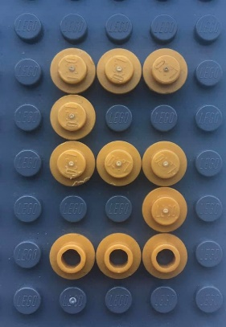
- Build something safe to store money in.
Even though the Temple looked grand and impressive, Jesus was sad at how dirty it had become. Not with mud or actual dirt; it was what some people were doing in the Temple that was messing it up. The people needed to buy sacrifices or gifts to give to God but the shop keepers in the Temple were cheating these people out of their money and stealing money for themselves. This was stopping people from using the Temple properly – the Temple was meant to help people worship God and pray to him. And the Temple leaders were letting this bad behaviour happen.
Jesus got angry about this. Very angry. He pushed the tables and chairs of the shop keepers over. Then he chased the shopkeepers away. Jesus spoke out, reminding the people that God had wanted the Temple to be a house of prayer, but they had made it into a den of robbers. This was Jesus’ way of cleaning things up.
I wonder what surprised you about this story?

- There are too many poorly people. Design an ambulance.
Jesus spent time at the Temple teaching people about God. Poorly people came to him – people who couldn’t walk very well or who couldn’t see – and Jesus made them better! Children were shouting happily in the Temple. “Hosanna!” they were saying, treating Jesus like a king.
When the other teachers and Temple leaders saw all that was happening in the Temple – how Jesus had treated the shopkeepers and how he was welcoming all kinds of people – they were worried. And when they saw how much the crowds liked Jesus they were afraid of Jesus. And they started to plan a way to get rid of Jesus. They decided they needed to arrest Jesus in secret and then kill him. But they would wait until the Passover festival had finished so that they did not annoy the crowds.
Imagine if Jesus visited where you live today: which people do you think he would help and spend time with?

- Jesus needs a place to stay. Create a home for him.
Jesus didn’t have a home of his own. He had spent the last three years traveling around the country, teaching people about God and doing wonderful miracles like making people better and feeding people. Because Jesus was always on the move, he would stay at different people’s homes. He depended on other people being kind to him.
During the Passover festival Jesus was staying just outside of the busy city. He was with his disciples – twelve of his friends who followed him everywhere, learning from him. They had all been welcomed into the home of Simon the Leper.
What things in your life are you thankful for?

- Can you build a container that can hold water?
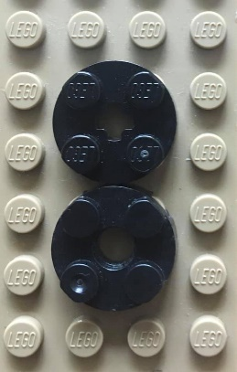
While Jesus was at the home of Simon, a woman came with a jar full of very expensive perfume. She broke open the jar and poured the perfume over Jesus’ head.
Some of the disciples thought this was a waste of good perfume and told the woman off. It was such expensive perfume!
But Jesus stopped them, saying that the woman had done a beautiful thing. He explained that she had been getting his body ready for being buried. Perfumes were poured on dead bodies to hide the smell of death. And Jesus knew he was going to die soon.
One of Jesus’ disciples, called Judas, secretly decided he didn’t want to be Jesus’ friend or follower any more. He went off to make a deal with the Temple leaders. He agreed to lead them to Jesus and they agreed to give him some money. Together they set a trap to catch Jesus.
Everyone is going to die at some time. What are your thoughts about death?

- Dining room needed! Can you build a table and some chairs?
Lots of people had travelled to the city of Jerusalem to celebrate the Passover. The Passover festival remembers a time long ago when God used a man called Moses to rescue his people. It is celebrated with a special meal and Jesus needed a place for him and his disciples to have the meal.
Even though Jesus did not have his own home, he told his disciples about a man who had a large upstairs room in a house in the city that would be just right for them to use. The disciples followed Jesus’ instructions and found that Jesus was right about everything. So they started getting ready for Passover.
Do you have a favourite meal, or a favourite memory of a meal?

- Design a meal out of Lego.
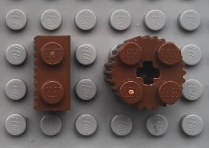
When it was evening, Jesus and his disciples gathered around the table to eat the Passover meal. Jesus had been looking forward to sharing this meal with his friends. This Passover meal would be his last meal. This is why it is sometimes called ‘The Last Supper’.
Jesus knew one of his friends had secretly turned against him and had made a deal to capture him.
While they were eating, Jesus gave thanks for the bread and broke it to share with his disciples. He said the bread was his body.
He then took a cup of wine, gave thanks for it, and shared it with the disciples. He said the wine was his blood, poured out for many.
Jesus knew this was his last supper.
How does it feel when one of your best friends stops being a friend?

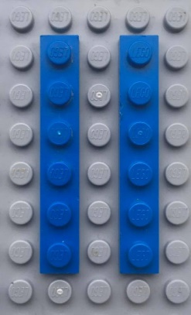
- Build a garden.
It was evening. After eating the Passover meal, Jesus and his friends went to the Garden of Gethsemane. This was a large and quiet garden, filled with olive trees. Jesus often visited it.
Jesus asked his disciples to keep watch while he went off on his own to pray. He was feeling a lot of different feelings and was scared about what he knew was going to happen to him. He prayed to God, telling God how he felt. Although he felt scared, he wanted to do what God told him to do. When he had finished praying he found that his disciples had fallen asleep.
Do you have a special place where you like to go to be by yourself?

- Can you design a weapon?
Jesus and his disciples had gone to the Garden of Gethsemane after their evening meal. Judas knew that Jesus liked to visit this garden and he had made a deal for Jesus to be captured there.
A small crowd appeared holding swords and sticks. Judas had told the crowd to wait for a special signal: a kiss. When Judas came up to Jesus, he greeted Jesus… with a kiss. The crowd stepped forward, grabbed Jesus and arrested him.
One of Jesus’ friends, called Peter, grabbed a sword and cut off someone’s ear. Jesus told Peter to put the sword away. Jesus explained that if he wanted all this to stop his heavenly father, God, could have sent down armies of angels to defend him. But all this needed to happen. So Jesus healed the man’s ear. And Jesus let himself be taken away.
If someone hurts or upsets you, what are some of the different ways that you could respond?

- It is dark and a campfire is needed. Please create one.
They had taken Jesus away for questioning. Peter, one of Jesus’ friends, decided to secretly follow them. He followed them to a house so he stayed outside.
Outside, a warming fire had been started and a small crowd had gathered around it, so Peter joined them. A girl thought she recognized Peter’s face in the light of the fire and told everyone that he was one of Jesus’ friends. But Peter said no, pretending that he didn’t even know Jesus. Later on, someone else linked him to Jesus. A second time, Peter said no. Another person noticed that Peter wasn’t from that area and said that Peter had definitely been with Jesus. A third time, Peter said no.
While Peter was speaking, a cockerel crowed. Suddenly Peter remembered that after their meal together Jesus had told him that before a cockerel crowed he would have pretended to not know Jesus three times. Peter got up and left, crying.
I wonder if you can think of anything you’ve said or done that you are sorry about
- Build a prison for a criminal.
The Temple leaders and other teachers really wanted to get rid of Jesus. Forever. But they were not allowed to kill anyone. Only the Roman governor had that power. So they took Jesus to Pilate, the Roman governor. They told Pilate that Jesus wanted to be king and that he had followers all over the country.
Pilate questioned Jesus. He didn’t think Jesus was that bad and he definitely didn’t think Jesus should be killed. But the Temple leaders kept arguing with him.
Every year during the Passover festival the Romans would release a prisoner that the people chose. So Pilate asked the crowds if they wanted him to release Jesus, their king. But instead of Jesus, the crowds asked Pilate to release Barabbas. Barabbas was in prison for fighting against the Romans, and he had even killed someone. Pilate was shocked and asked the crowds what he should do with Jesus. “Kill him!” the crowds shouted. “Kill him!”. So Barabbas, a criminal, was released, and Jesus took his place.
When was the last time you said or thought “That’s not fair!”?

- A king needs a crown. Design a crown.
The Roman soldiers took Jesus’ clothes off and put a robe on him like a king might wear. They made a crown using sharp thorns and pressed it on his head. They teased Jesus and made fun of him, hurting him with their words. Then they hit him and spat on him, hurting him with their actions.
They took Jesus to Golgotha. Golgotha means “place of the skull” and it was the place where the Romans killed criminals. They killed the criminals in a very painful way by hanging them on wooden crosses. Even though Jesus hadn’t done anything wrong and wasn’t a criminal, they nailed Jesus onto a cross. Jesus said to God, “Father, forgive them.” Two criminals were also being killed that day and were placed each side of Jesus. They hung a sign on Jesus’ cross to let everyone know what he was being punished for. The sign said, “This is the king of the Jews”.
The crowd that had gathered to watch and the Roman soldiers and even one of the criminals teased Jesus, saying if he really was the king sent by God he should be able to save himself.
What surprised you most about this part of the story?

- What would a Lego earthquake look like?
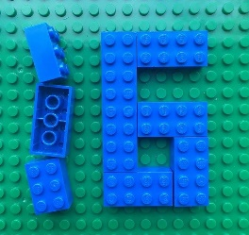
Lots of strange things happened when Jesus died.
One of the criminals dying next to Jesus recognized he was getting what he deserved but that Jesus had done nothing wrong. He asked Jesus to remember him when he came into his kingdom. Jesus answered by inviting this criminal to join him in heaven.
At midday, darkness covered the land and it stayed dark for three hours. At about three o’clock in the afternoon Jesus cried out in a loud voice and breathed his last breath. At that moment, the ground started shaking and rocks split open. A heavy curtain in the Jerusalem Temple that kept people away from the most special room was ripped into two pieces from top to bottom, and a new way was open to God.
A Roman centurion was there guarding the cross. When he saw what happened and how Jesus died he was terrified. He then praised God, recognising that Jesus had done nothing wrong and wondering if perhaps Jesus really was the Son of God.
I wonder if Jesus really was the Son of God?

- A dead body needs respect. Can you build a coffin?
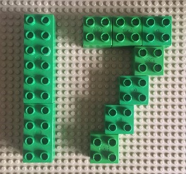
Joseph had been a secret follower of Jesus. When Jesus died he was brave and went to Pilate to ask for Jesus’ body. Most criminals were not given a special burial but Joseph wanted Jesus to be treated with respect. So he wrapped Jesus' body in linen cloth and placed it in a tomb. The tomb was cut out of rock and was in a garden. Then a large stone was rolled in front of the entrance of the tomb.
Jesus had known he was going to die. He had warned people that he would be killed and he also told people that he would not stay dead but come back to life three days later. The Temple leaders asked Pilate to order some soldiers to guard the tomb. They were worried that Jesus’ disciples might try to steal Jesus’ body and then lie to people, pretending that Jesus had come back to life.
Joseph had to get Jesus’ body ready in a hurry. This was because it was nearly the Sabbath, their day of rest when everyone stops working.
Why is it important to spend time resting?

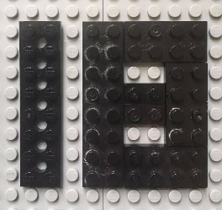
- The Grand Finale: build an Easter egg or a basket full of eggs!
After the Sabbath rest had finished, some women who had been followers of Jesus went to Jesus’ tomb. It was early in the morning, a Sunday. They were bringing perfume to put over Jesus’ body and had been wondering who would roll away the big stone.
They found the stone already rolled away. They went inside the tomb. Jesus’ body was not there! A man dressed in shining white was suddenly next to them. He was an angel! He told the women not to be scared. He knew they were looking for Jesus who had been killed on the cross. He told the women Jesus had risen. Jesus had come back to life! He showed them the empty place where Jesus’ dead body had been. And then he told the women to go and tell Jesus’ disciples.
Sunday has become a special day for Christians because it was the day when Jesus came back to life. It’s a celebration day! To help celebrate, many of us have chocolate Easter eggs at Easter to remind us of the cave Jesus’ body was put in and also the stone that was rolled in front of it. The best Easter eggs are hollow – empty inside – reminding us of Jesus’ empty tomb. Eggs are also a sign of new life. Easter eggs remind us that Jesus came back to life and that he is offering us a new life with Him.
What are you celebrating this Easter?

