PARISH OF
St Paul’s Letchworth

REVISION OF CHURCH ELECTORAL ROLL

Notice is hereby given
that the Church Electoral Roll of the above parish will be revised by the Parochial Church Council*, beginning on 16th September 2020, and ending on 29th September 2020.
* The revision must be completed at least 15 days, but no more than 28 days, before the Annual Parochial Church Meeting.

After the revision, a copy of the Roll will be published by the Parochial Church Council in the Church for at least 14 days and a copy of the Roll will be available for inspection on a reasonable request being made to the Council.

Under the Church Representation Rules any lay persons are entitled to have their names entered on the roll if the person is—
(a) is baptised,
(b) is aged 16 or over, and
(c) has made one of the following three declarations and duly applied for enrolment.

The first declaration is that the person is a member of the Church of England or of a Church in communion with it and is resident in the parish.

The second declaration is that the person is a member of the Church of England or of a Church in communion with it, is not resident in the parish, but has habitually attended public worship in the parish during the preceding six months.

The third declaration is that the person is a member in good standing of a Church which is not in communion with the Church of England but subscribes to the doctrine of the Holy Trinity and is also a member of the Church of England and has habitually attended public worship in the parish during the preceding six months.

Application Forms for enrolment can be obtained from the Church Electoral Roll Officer. In order for a person to be entitled to attend the annual parochial church meeting and to take part in its proceedings, an Application Form for enrolment must be returned by the date shown above for the ending of the revision of the Church Electoral Roll by the Parochial Church Council.

Any error discovered in the Roll should at once be reported to the Church Electoral Roll Officer.
At least 14 days’ notice must be given.
Dated this 2nd day of September 2020

Signed 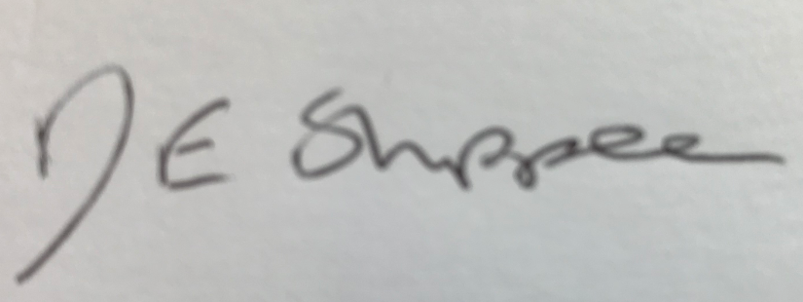

Address : 73 Wilbury Road, Letchworth Garden City, SG6 4JJ
Church Electoral Roll Officer

